EXPERIMENT NO. 7 / 8
UML Sequence Diagram & Collaboration Diagram
Project: Hospital Management System (HMS)
Prepared by: Anish Chitnis (24CE1044) | Aaryan Choube (24CE1045) | Somansh Dafade (24CE1047)
Batch: A / A1 | Dept of Computer Engineering, RAIT, DY Patil University
1. Aim
To model dynamic time-ordered and link-oriented object interactions in the Hospital Management System (HMS) using UML Sequence and Collaboration (Communication) diagrams.
2. Objectives
• To construct a Sequence Diagram displaying chronologically ordered message exchanges across boundary, control, and entity objects.
• To construct a Collaboration Diagram highlighting structural organization and numbered message links.
• To model real-time transactions: appointment scheduling, consultation charge aggregation, and payment gateway authorization.
3. UML Sequence Diagram
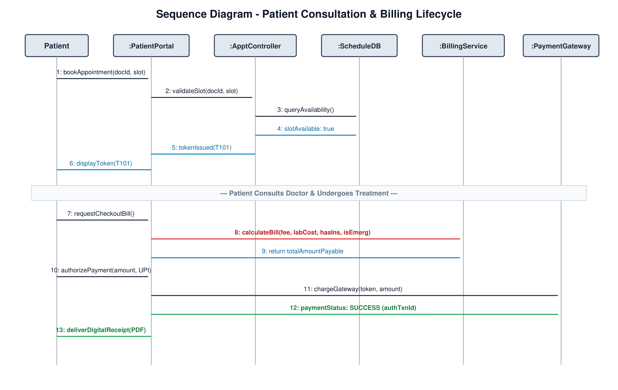
Fig 1: Sequence Diagram - Patient Consultation & Billing Lifecycle (HMS)
Message Flow Analysis:
• Messages 1–6 (Scheduling): Patient triggers bookAppointment via PatientPortal. ApptController queries ScheduleDB, reserves slot, and returns token.
• Consultation Phase: ConsultationService updates EHR records and posts consultation fee to BillingService.
• Messages 7–13 (Billing & Settlement): calculateBill executes with parameters (fee, labCost, hasIns, isEmerg). Patient authorizes UPI transaction, PaymentGateway returns approval token, and invoice is generated.
4. UML Collaboration Diagram
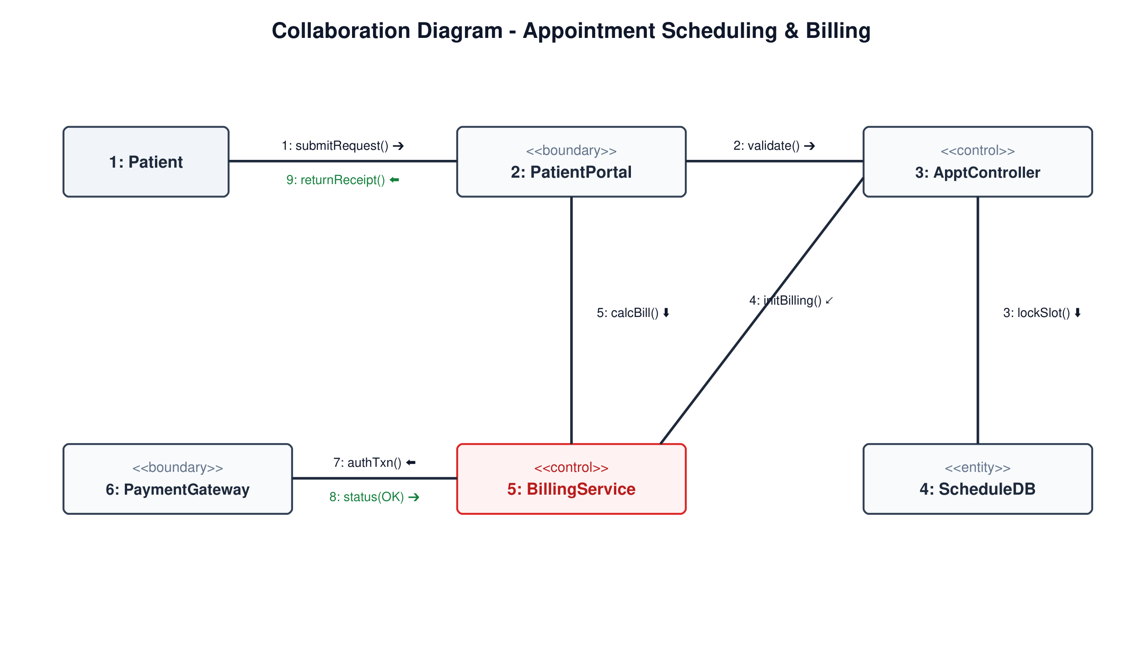
Fig 2: Collaboration Diagram - Appointment Scheduling & Billing (Link-Oriented)
Sequence vs Collaboration Diagram Comparison:
Comparison Parameter | Sequence Diagram | Collaboration / Communication Diagram
Primary Emphasis | Time sequence of messages (top to bottom timeline). | Structural relationships and links between interacting objects.
Lifelines & Activation | Explicit vertical lifeline bars showing object lifetime and active execution. | Objects represented as icons/rectangles; lifelines are omitted.
Message Numbering | Optional, as chronological order is implicit in vertical placement. | Mandatory numbered decimal prefixes (e.g., 1:, 2:, 3:) to indicate message sequence.
Suitability | Best for detailed execution traces and timeout/loop modeling. | Best for understanding object collaborations and structural impacts of design changes.

5. Conclusion
The Sequence and Collaboration diagrams provide complementary perspectives on runtime interactions in HMS, verifying seamless coordination between scheduling, clinical recording, and financial transactions.

